Projects
Project 1:
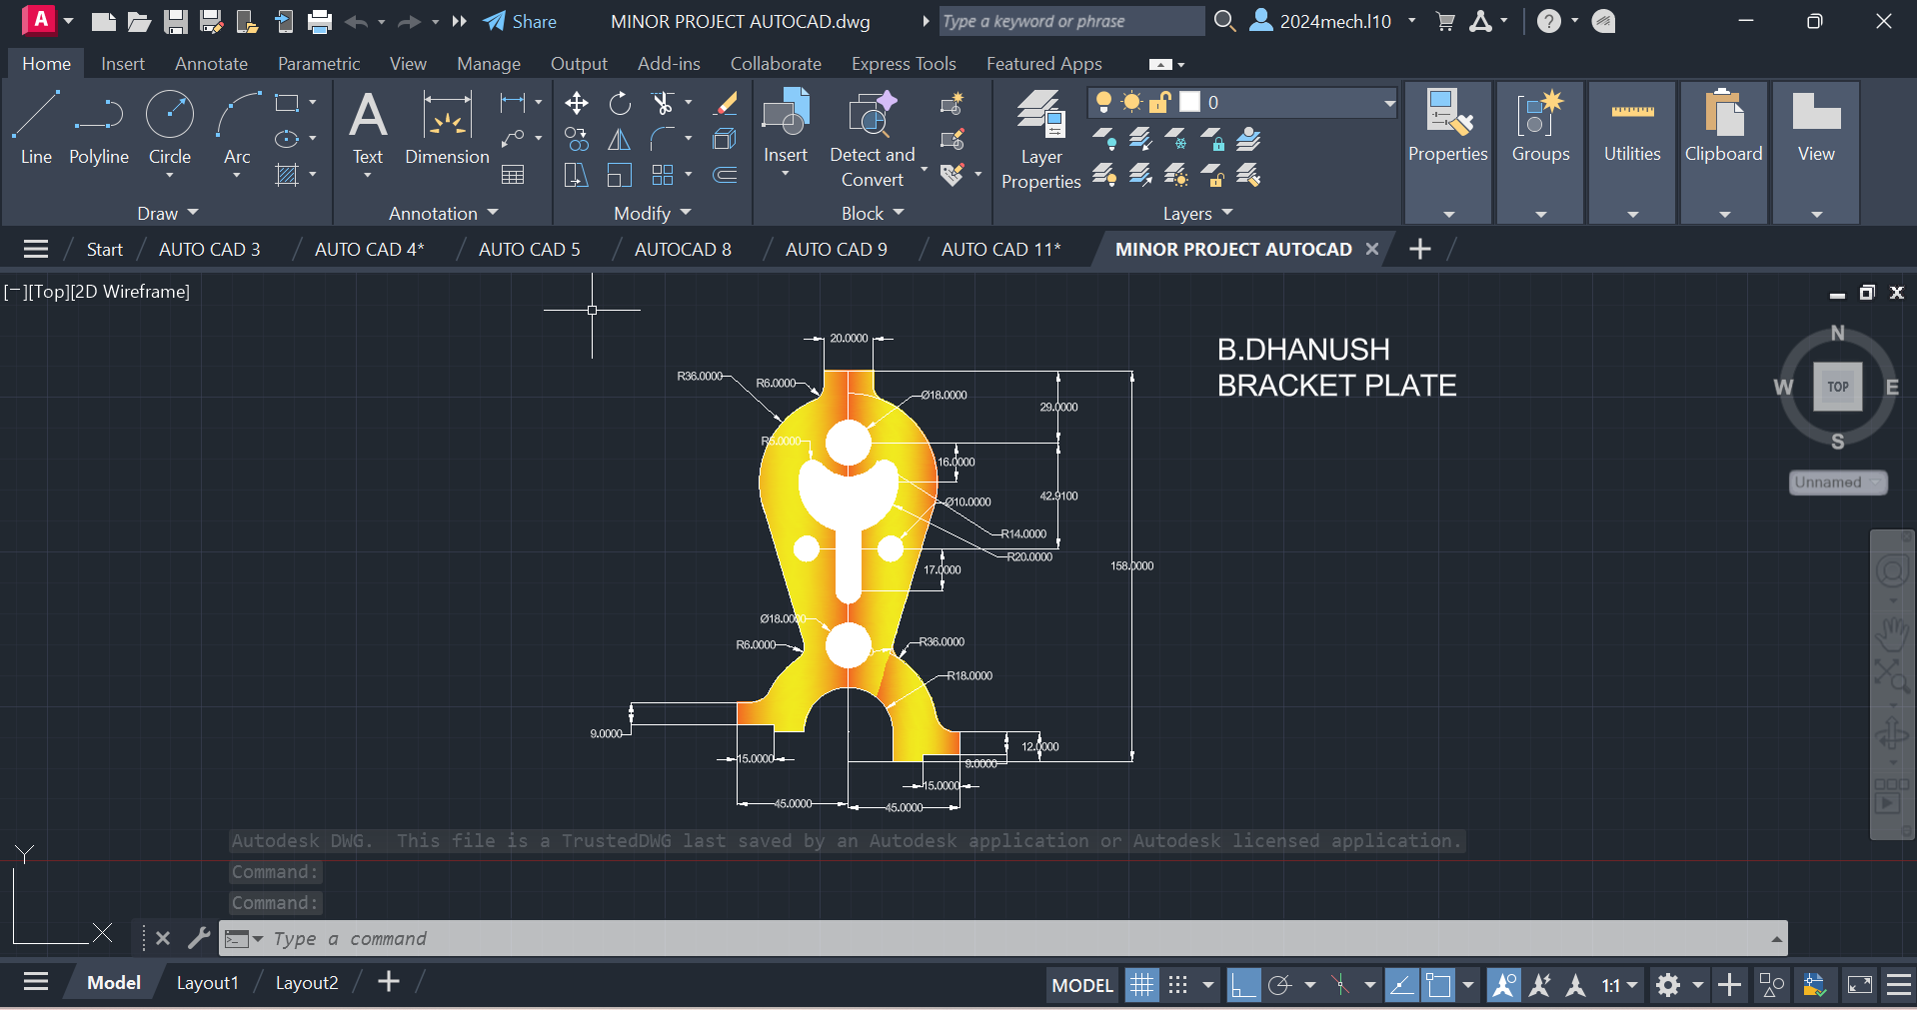
Procedure :

- First of all open autocad software in the laptop or in desktop .
- After opening, click on new the above page will appear in screen.
- If you don’t need grapical page click on ‘F7’ the grapical page will disappear in screen.
- After that press on letter ‘L’ for line command or you can directly click on line command which will be available in command box.
- Using line command draw the diagram with required dimensions.
- use the circle,trim and arc commands, where it is needed.
- change the dimensions and units by clicking letters ‘Dim’ for ‘Dimensions’ and ‘U’ for ‘Units’ after clicking change the units.
- After drawing the diagram save it in laptop or in desktop.
Project 2:
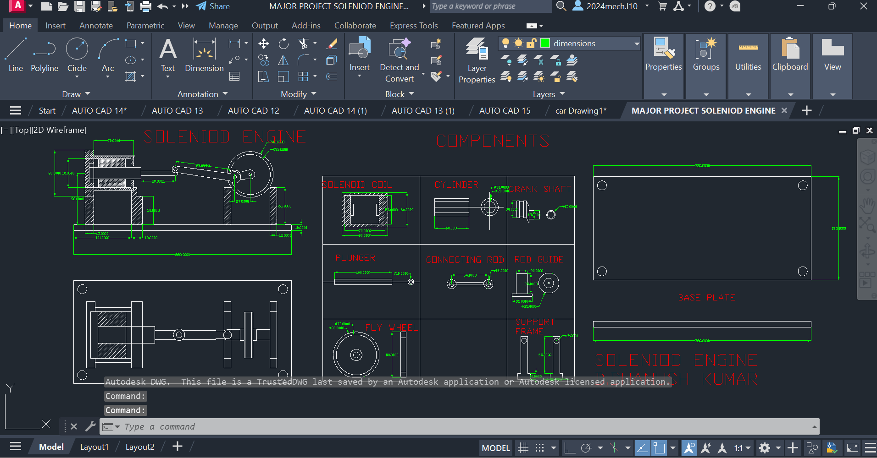Procedure :
- First of all open autocad software in the laptop or in desktop .
- After opening, click on new the above page will appear in screen.
- If you don’t need grapical page click on ‘F7’ the grapical page will disappear in screen.
- After that press on letter ‘L’ for line command or you can directly click on line command which will be available in command box.
- Using line command draw the diagram with required dimensions.
- use the circle,trim and arc commands, where it is needed.
- change the dimensions and units by clicking letters ‘Dim’ for ‘Dimensions’ and ‘U’ for ‘Units’ after clicking change the units.
- After drawing the diagram save it in laptop or in desktop.
SOLIDWORKS

PROJECT 1

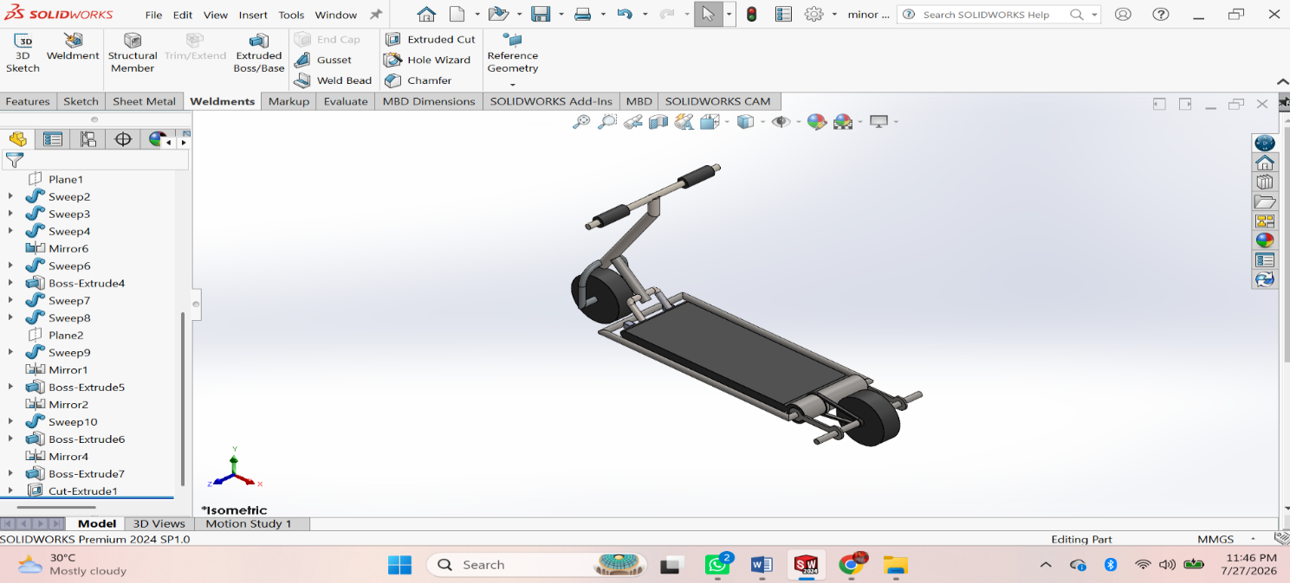

Procedure
- First of all open solidworks software in the laptop or in desktop.
- After opening, click on new the above page will appear in screen.
- After that click on frount view the sketch chuck box will be appear click on it for further step.
- In that page a small rectangular box will appear at above the date and time box, there change the units from ‘MKS’ to ‘MMGS’ units.
- Using ‘Circle’ command draw the diagram with required dimensions by giving alignments to circle.
- After drawing open ‘Extrude’ command and extrude upto required dimensions.
- After that click on top of the extrude part, a sketch box will be appear click on it.
- Again Use Line command and draw the next swept part.
- After drawing, by using ‘swept’ command draw the thread upto required dimensions.
10. After drawing the diagram save it in laptop or in desktop.
PROJECT 2
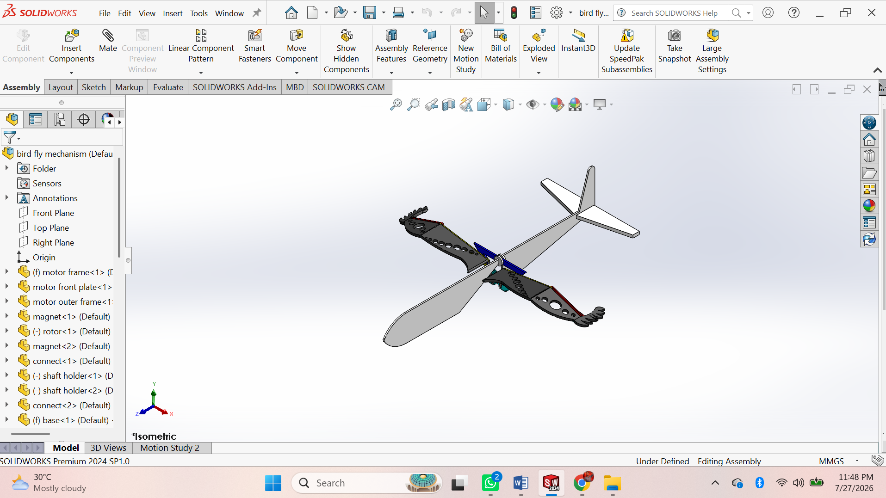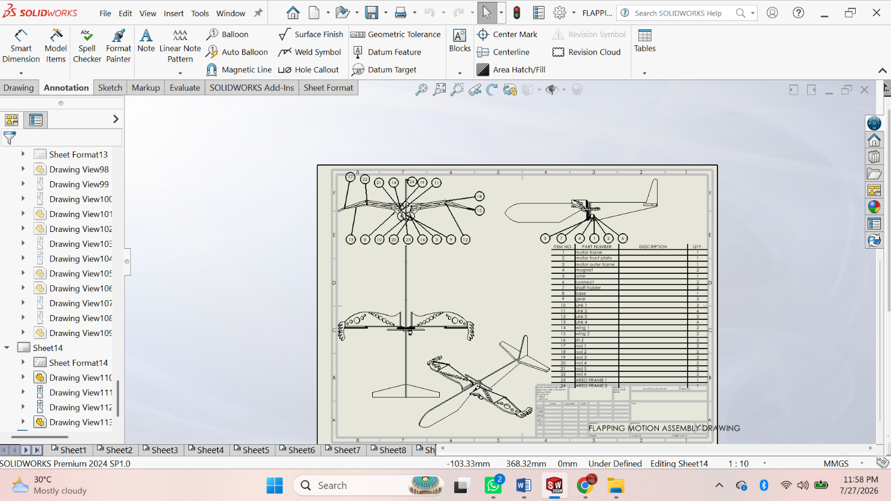

Procedure
• Create all Parts – Base, Frame, Crank, Shaft, Connecting Rod, Wing Link, Wing, Pins, Bushes, and Fasteners.
• Save each part as .SLDPRT.

Assembly

• File → New → Assembly.
• Insert Base and Fix it.
• Insert Frame – Apply Coincident Mate.
• Insert Shaft – Apply Concentric Mate.
• Insert Crank – Apply Concentric and Coincident Mates.
• Insert Connecting Rod – Apply Concentric Mate.
• Insert Wing Link – Apply Concentric Mate.
• Insert Left and Right Wings – Apply Hinge (Concentric) Mates.
• Insert Pins, Bushes, and Fasteners – Apply Concentric and Coincident Mates.
• Apply Mechanical Mates (Hinge/Limit Angle/Gear Mate if required).
• Check Interference – Evaluate → Interference Detection.
• Create Motion Study – Add Rotary Motor to the crankshaft and run the simulation.
• Save the Assembly (.SLDASM) and create the Assembly Drawing with BOM and Balloons.

